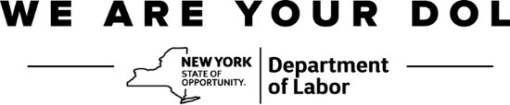
Purchase & Contracts, SDVOB Administrator
Harriman State Office Campus,
Building 12, Room 454
Albany, NY 12240
Phone: (518) 474-2678 | Fax: (518) 457-0620
Labor.sm.SDVOBAdmin@labor.ny.gov

Instructions for Completing the
Monthly SDVOB Compliance Report – SDVOB 101
 | The SDVOB Monthly Reporting Form is to be completed by the Contractor/Vendor, and submitted by the 10th day of each month for the duration of the Contract. This form should include all (e.g. SDVOB and non SDVOB) Subcontractors and/or Suppliers assigned by the Contractor/Vendor to perform work during the contract. This reporting should also include payments made by your Subcontractors and/or Suppliers to SDVOB firms.
 | Complete the form as specified below.
Contract No. |  | Indicate the NYS Department of Labor’s Contract No.
Contractor/Vendor Name and Address |  | Provide your firm’s name and address.
Federal ID No. |  | Enter your firm’s Federal ID No.
Goals |  | Indicate SDVOB participation goals.
Reporting Period |  | Fill in the month and year of reporting period. One copy must be submitted with final payment application.
Description of Project |  | Briefly describe the work you are providing under the terms of this contract.
Firm Name and Address |  | Provide the name, address and phone number of all Subcontractors/Suppliers assigned by the Contractor/Vendor on this contract or purchase agreement(s).
Federal ID No. |  | Enter the Subcontractor’s/Supplier’s Federal ID No. If no Federal ID No. has been assigned, provide only the owner’s last four (4) digits of his or her Social Security No.
Payment This Month |  | Indicate the amount paid this month to each Subcontractor/Supplier. If there was no income activity for a Subcontractor/Supplier, please check the box indicating “No Payment This Month.”
Contract Amount |  | Enter the total contract amount or purchase agreement(s) amount for each Subcontractor/Supplier.
Description of Work/Supplies |  | Briefly describe the work performed or supplies provided by each Subcontractor/Supplier.
Submit to:

NYS Department of Labor
SDVOB Administrator
State Office Campus, Bldg 12, Room 454
Albany, NY 12240
Email: labor.sm.SDVOBAdmin@labor.ny.gov
Fax: (518) 457-0620

